Assignment 5

1. This Alteryx workflow shows how I input, cleaned, and prepared addresses of beauty retailers in or near my target zip code 87121. Using these store addresses, I will evaluate which location could be the best partner site for my cosmetics/skincare outreach initiative.

My chosen beauty retail partner, one of the three stores listed above (Sally Beauty, Sunficent LLC, or Ulta Beauty), will serve as the distribution hub for offering discounted or free skincare kits and educational materials to Hispanic women aged 15–44, my project’s user group. These products will also be available to any other residents in the area who may benefit from improved access to skincare resources and education.

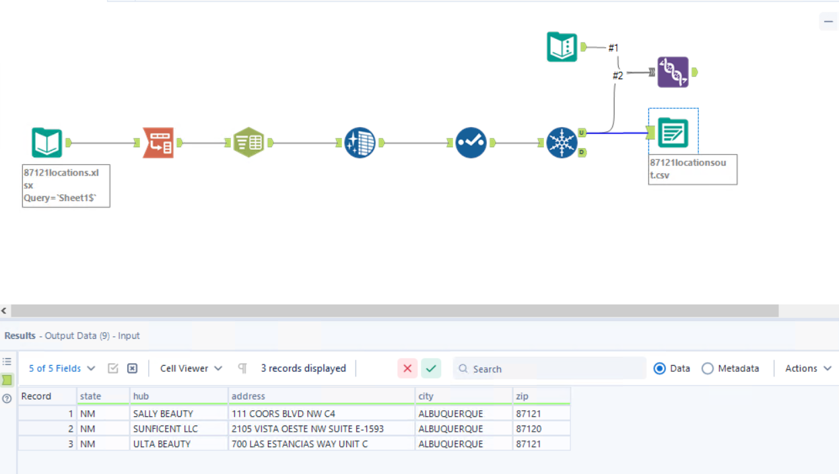

1. This map shows 3 beauty retail stores in or near my target zip code 87121, which is home to a large portion of my user group (Hispanic females aged 15–44). Also displayed is the 1-mile radius trade area around each store, after using a Remove Overlap function to eliminate overlapping regions. This ensures I do not double count users or potential skincare outreach impact within those shared zones.

I will select the best of these 3 trade areas to serve as the first local hub for distributing discounted skincare kits and educational materials as part of my project. This map helps visualize geographic coverage and avoid redundancy in outreach zones.

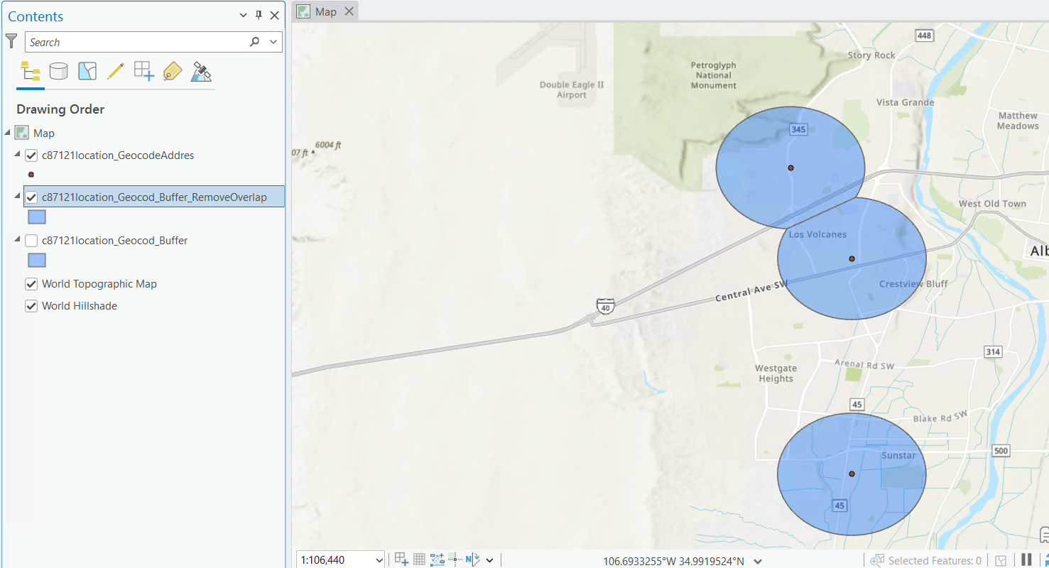

1. The Sunficent LLC location at 2105 Vista Oeste NW, Ste E, Albuquerque, NM is the best trade area for my project among the three beauty retail locations I considered in or near my target zip code of 87121. Based on this store’s 1-mile fixed-radius trade area, it has the highest forecasted annual sales of my focal product—cosmetics/skincare products—at $1,693,425. This trade area also demonstrates strong user group metrics: 2,639 Hispanic females aged 15–44 live within this area, accounting for 13.59% of the total population, and it has the highest average annual spend per household at $231.50.

While Sally Beauty has a larger number and percentage of Hispanic females aged 15–44 in its trade area (3,299 individuals and 17.79%), I selected Sunficent LLC as my project partner due to its significantly higher projected total cosmetic sales and greater household-level spending, making it the most promising site for impactful and sustainable outreach.

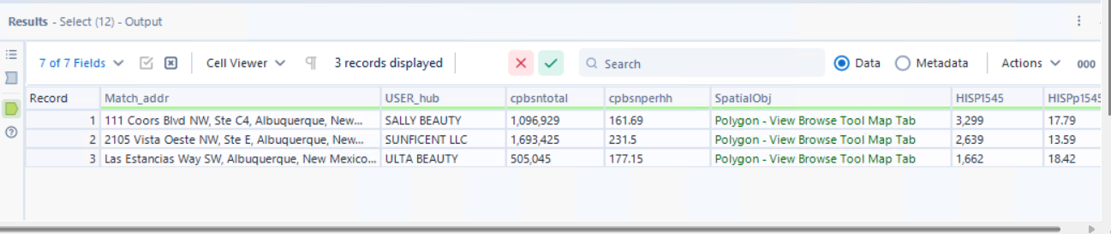

1. I estimate that the average annual spend on cosmetics/skincare per buyer is approximately $1,000, based on industry research and typical consumer behavior in personal care product categories. To estimate the number of potential skincare buyers in the trade area around Sunficent LLC, I take the total forecasted annual cosmetic spend in the trade area ($1,693,425) and divide it by $1,000 per buyer.

As a result, I forecast approximately 1,693 total skincare buyers in the trade area. This estimate includes anyone likely to buy skincare products, regardless of whether they fall within my core user group of Hispanic females aged 15–44. This broader potential reach reinforces the trade area’s value for launching my outreach initiative.

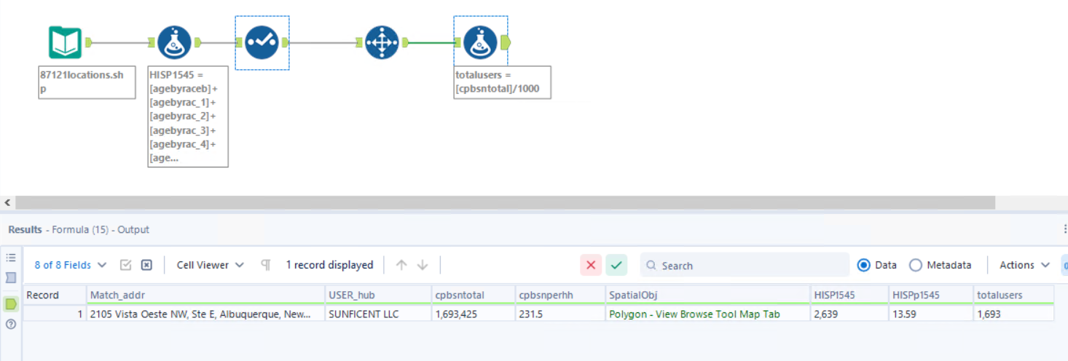

1. I estimate that, when I reach all potential skincare buyers in this trade area, 230 of those buyers will be Hispanic females aged 15–44, which is my target user group. I obtain this estimate by multiplying the total number of skincare buyers (1,693) by the proportion of the population in this trade area who are Hispanic females aged 15–44 (13.59% / 100 = 0.1359).

This is shown in the formula above as:  
HISPusers = [totalusers] \* ([HISPp1545]/100)

This calculation helps me estimate the number of buyers in my user group, allowing me to better size the outreach and resource needs for my project.

